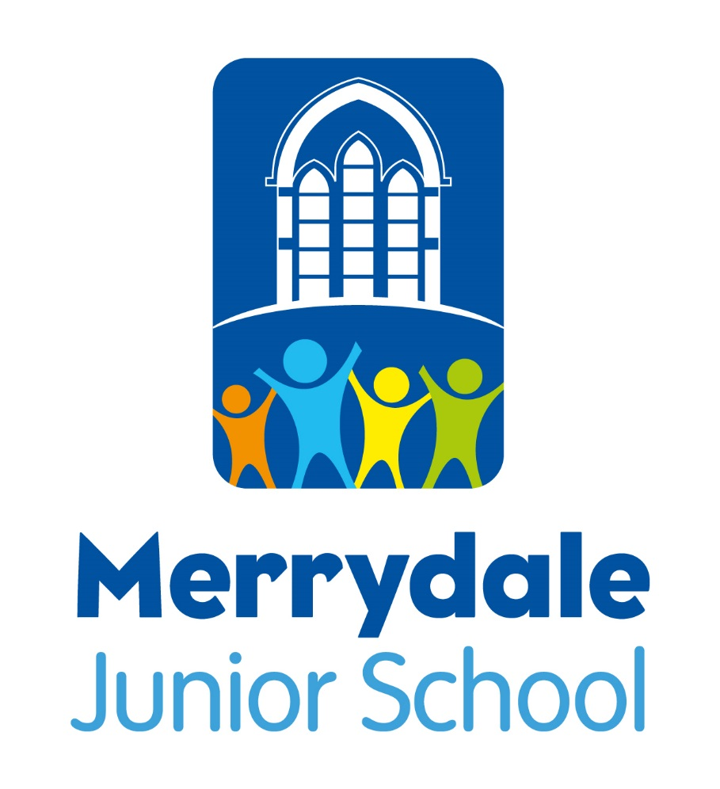

Reading Policy
2023-24

Headteacher: Antony Corbett

Policy Date: | September 2023 |  | Version: 2 – AC
Policy Review Date: | September 2024 |  | Antony Corbett
Ratified by Advisory Board:




Reading Policy

Introduction

This policy reflects the school’s aims and objectives in relation to the teaching and learning of Reading. It sets out a framework within which teaching and non‐teaching staff can operate. It gives guidance on planning, teaching and assessment. The policy should be read in conjunction with the National Curriculum which sets out the rationale for teaching each area of the English Curriculum and specifies the skills that will be developed for the majority of pupils in each year group. This document is the outcome of consultation and review undertaken by the English subject leader with the staff. At Merrydale Junior School we use the new National Curriculum for English (2014) as the basis of our English programme.

We supplement this with the Discovery Schools Academy Trust ‘Language Comprehension Framework’.

Reading is a complex skill with many components. Successful approaches to the teaching of reading should encourage children to use a variety of strategies in their pursuit of meaning. It is important to lay firm foundations in this crucial area of the curriculum and establish a consistent whole school/Trust approach to the teaching of reading.

The policy document is designed to ensure that Merrydale Junior School meets the needs of all pupils, taking into account their individual contexts and strengths. It is important that we meet the diverse needs of all pupils to ensure inclusion for all and that all pupils can confidently apply all reading skills.

We therefore aim to ensure that all children:

- are given access to read quality age-appropriate books.
- receive quality first teaching and high-quality modelling of all of the skills required to become a proficient reader, these include:
- To give / explain the meaning of words in context
- To retrieve and record information / identify key details from fiction and non-fiction
- To summarise main ideas from more than one paragraph
- To make inferences from the text / explain and justify inferences with evidence from the text
- To predict what might happen from details stated and implied
- To identify / explain how information / narrative content is related and contributes to meaning as a whole
- To identify / explain how meaning is enhanced through choice of words and phrases
- To make comparisons within the text
- have the opportunity to develop reading accuracy, fluency, and understanding.
- develop the ability to use and manipulate a variety of texts, both fiction and non-fiction.
- are given time to read at school.
- are given extra support with reading at school (when they are not so well supported at home)
- acquire a love of texts and reading.
- develop the independence to apply all of the reading skills taught in school.

The Merrydale Junior School curriculum for reading consists of two dimensions:

- word recognition
- language comprehension

It is essential that teaching focuses on developing pupils’ competence in both dimensions; different kinds of teaching are needed for each.

. 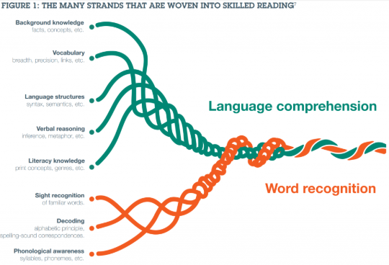
(Scarborough, 2001)

Word Reading

Skilled word reading involves both the speedy working out of the pronunciation of unfamiliar printed words (decoding) and the speedy recognition of familiar printed words (sight vocabulary). Underpinning both is the understanding that the letters on the page represent the sounds in spoken words. This is why phonics should be emphasised in the early teaching of reading to pupils who are new to English.

Word Recognition comprises of three elements:

- Sight words
- Decoding strategies
- Phonological awareness
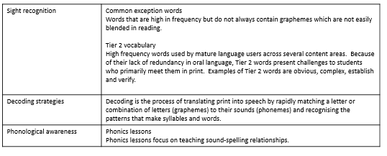

Phonics Support

From August 2022 the school decided that Read, Write, Inc. is the phonic system that will be used in school. We have also followed the main feeder Infant school who have also taken Read, Write, Inc. as their main phonic strategy. All staff were trained on the August teacher days. We have received support from RWI and this continues throughout the year.
As the feeder Infant school progress through their RWI strategy the assessment of children will become smoother. We anticpate that the sharing of assessments will also be easier. Currently we screen all Year 3 pupils who were still receiving RWI as their primary English lessons from the Infant school in September. We use the phonics assessment from RWI. The school SENDCo oversees this process and ensures consistency across the evaluation process. The SENDCo also organises the groupings for any phonic interventions that will be happening. phonics provision.
Phonic interventions are then put in place to meet the specifc needs of our children.

Language Comprehension – Guided reading.

The DSAT ‘Language Comprehension Framework’ has considered the National Curriculum’s Programme of Study and the Content Domains identified in the Reading Test Developer’s Frameworks for KS2.

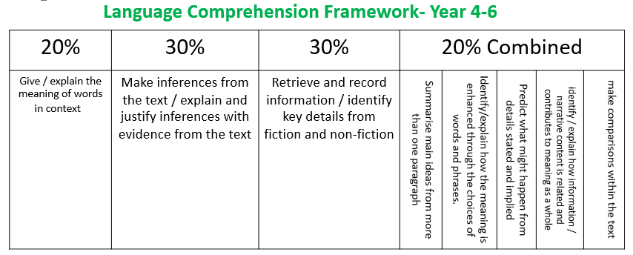

The DSAT ‘Language Comprehension Framework’ acts as a basis for the teaching of language comprehension and should be developed to balance the child’s reading entitlement to a broad and varied curriculum whilst reflecting the rigour and expectations of the milestone assessments which they will encounter during their journey through the primary phases of their education.

Throughout the week children are given direct teaching and practice of the key skills (i.e. vocabulary, retrieval and inference), as well exploring the other content domains.

Year Group Progression

Teachers will be required to teach children the different content domains in order to help the children’s language development and understanding. The % given for each content domain reflects the weighting of the specific skill within the teaching sequence and therefore the amount of time needed to be focused on each of them. (The school’s ‘Reading Progression Map’ equips teachers with a clear progression of expectations and appropriately pitched questions.)

This cycle will be repeated throughout the year and reflected in the planning and delivery of lessons which develop language comprehension (whether in English, reading or cross-curricular lessons).

Guided Reading Models

All classes at Merrydale Junior School, receive thirty minutes of high-quality guided reading teaching, nine times over a two-week cycle.

Year groups will look to use One note where applicable to enhance blended learning opportunities in reading. This is not appropriate for all year groups and ability levels. The year groups will look at addressing the vocabulary around the text in the initial phase of the two week block. Year groups will look at fluency activities when they fit into the teaching sequence best. This will be decided by the year groups during planning. Fluency is a separate lesson, whereby children are explicitly taught how to read aloud fluently, looking at word or syllable emphasis and the use of punctuation. This is also covered every day in the revisiting of the text (where appropriate).

Majority of class – Whole class (content domain-based) shared/guided lessons ensure that the children understand the specific skills of language comprehension and are confident in the rigour, pace and expectations of the end of year group assessments.
Targeted guided reading groups - Mixed age groups where the focus is still on the content domain but the texts have been selected to reflect the needs of the children. The texts are high interest texts to ensure engagement. Year groups can also use texts from tests following the children taking the tests. They are also free to share the mark schemes from the tests to help the children understand how to improve.
Targeted SEND guided reading groups - Mixed age groups where the focus is still on the content domain but the texts have been selected to reflect the SEND needs of the children.

Guided groups for children who are below age-related.

There are a group of children who need a little more than phonics but are not yet ready for the class reading sessions. This group will receive the RWI fresh start comprehension scheme and we will look to accelerate these children back into class.

Monitoring

It is essential that staff observe and assess the children as part of their everyday practice. In order to capture in the moment observations, teachers take relevant notes about children they have either supported in guided reading sessions and/or when hearing children read 1 to 1. This information, along with data from Accelerated Reader quizzes, ‘Star Reader’ tests, and ‘Rising Stars’ (termly) assessments contribute towards the teachers’ assessments of the children’s reading skills. Such monitoring allows teachers to identify any difficulties or strengths that individual children have with reading.

The Reading Environment

A set of posters for KS2 have been created, showing visually the content domains. At Merrydale Junior School, we use these posters as part of our reading environment and reference them during our reading lessons.

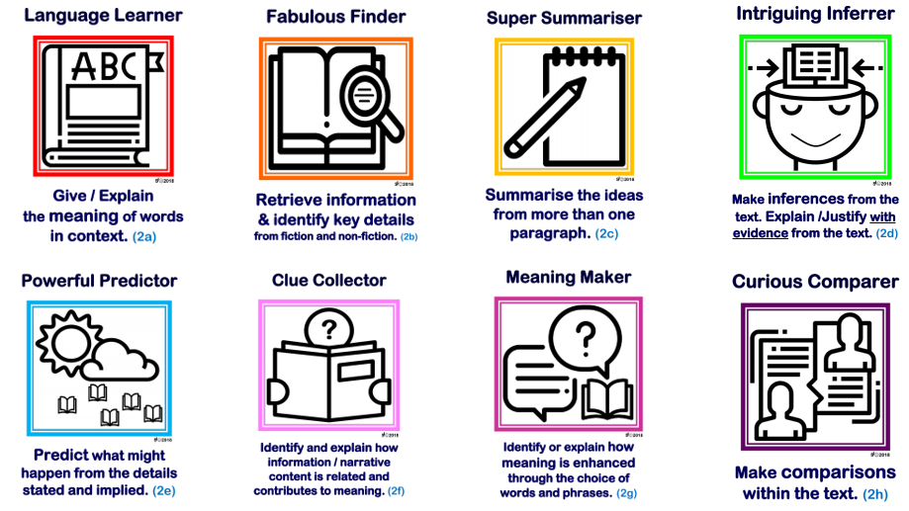

Fluency Facilitator

(Fluency)

Each class has a dedicated reading area which includes a wide variety of books matched to the Accelerated Reading scheme (including fiction and non-fiction) that span a range of reading difficulty. (These books may be divided into a “core” collection and a “revolving” collection. As with a library, the core collection is the permanent collection, available throughout the year. The revolving collection, on the other hand, changes every few terms, based on the topics to be studied in class at Merrydale.

‘Accelerated Reading’ at Merrydale Junior school

At Merrydale we follow the accelerated reading system. Each day the children are given the opportunity to read an accelerated reader book, complete an on-line quiz and then swap the book they are reading. The on-line quizzes give regular feedback upon how well the children are doing. This opportunity is given in the first fifteen minutes of the day and encourages reading at home. The accelerated reader quizzes also provide teachers with data on performance for the children in their classes. This provides valuable insights when assessing reading. All children will complete the star reader tests and will have an accelerated reader book. All reading books in classrooms are matched to the Accelerated Reading scheme. Children who are below accelerated reader thresholds will have a RWI book that supports their needs.

Assessment of Reading

Merrydale Junior School use the DSAT ‘Reading Teacher Assessment Frameworks for Reading’. These reflect the national, local and school developments in the assessment of reading. Accelerated Reader and teacher knowledge of the children are also used to gather additional assessment evidence.

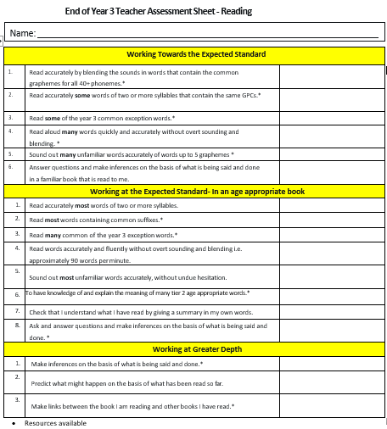

Accelerated Reader Assesments

The children of Merrydale will complete a star reader test four times throughout the year. This provides teachers with important data on progress. Each quiz the child completes also builds up a profile of information about the child’s performance through out the reading year. It is expected that childrens’ reading perfomance will improve with each assessment – teachers will assess this data and will support children who are not making the expected progress.

Rising Stars Tests

As part of the Discovery Schools Academy Trust we complete ‘Rising Stars’ tests three times a year. This shows teachers any gaps that children may have in their reading knowledge and skills. This is then addressed through the planning of guided reading sessions.

Differentiation and Inclusion

In accordance with the school’s policies on SEND and Equality, all children are entitled to access reading at an appropriate level for their age and development. Activities are differentiated where possible both for the less able and more able. Differentiation is through resources used, the difficulty of the task, support given and outcome. Notice is taken of targets within a pupil’s PEP. Provision is made, when necessary, for pupils to extend their experiences beyond that of the majority of the class - by providing further challenge.

The school’s ethos on equal opportunities aims is to eliminate unlawful racial discrimination and to promote equal opportunities and good race relations in all areas of school life. All pupils are expected to achieve the highest standards possible regardless of race, culture, gender or disability. Whenever possible materials and images used reflect a varied cultural dimension e.g. fruit from different cultures or learning about scientists from around the world. School staff are fully committed to ensuring all pupils regardless of their differences have the opportunity and support necessary to enable them to achieve their full educational and social potential.

Love of reading

As a school we constantly seek to develop the love of reading. In order to do this we read exciting and engaging books to our children, suggest books for children to read (e.g. ‘Mr Corbett’s Picks’), and support events such as the ‘World Book Day’. We encourage children to read a diverse array of books through a termly book choice supported by a staff member. We are continually developing the library area and reading environments within our classrooms.
Whole class reading by the teacher -

ROLE OF ADVISORY BOARD

The purpose of the Advisory Board is to ensure the implementation of the National Curriculum and to review the policy. Additional meetings may be held to discuss English (Reading) priorities across the school and to gain an overview of the teaching and learning of English (Reading).

MONITORING OF POLICY

We are aware of the need to monitor and update the school's Reading Policy on a regular basis, so that we can take account of improvements made in our practice and to changes in assessments, materials and government requirements. We will therefore review this policy at least once a year. The member of staff with responsibility for reading is the Deputy Headteacher – Antony Corbett.

Reading throughout the school, and how it reflects this policy, will also be reviewed throughout the school year in the following ways:

- Advisory Board work scrutiny
- School Improvement Partner
- DSAT peer reviews
- SLT/staff work scrutiny
- KS2 internal moderation
- KS2 external moderation
- Moderation with other schools (both within DSAT and the school’s city development group)
- Learning walks

REVIEW

This Policy will be reviewed in September 2024 (or sooner, only if national legislation / policy demands it).

Signed: ____________________________________________ Date:

Chair of Advisory Board

Signed: 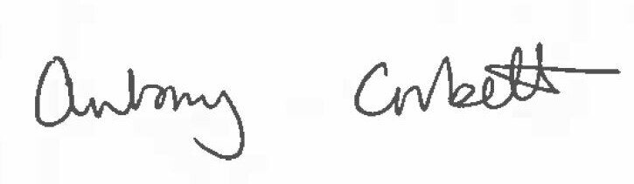 Date: 21st September 2023

Headteacher

