1

Accessibility Plan

Merrydale Junior School

2024 - 2027

Headteacher:

Antony Corbett

SENDCo:
Gemma Bryans

Tel:
0116 2767708

Email: office@dsatmerrydale.org

Prepared by:

Louise Saunders

Reviewed
:
March 2024

Approved by:

Advisory Board

Next review date:

March 2027

Document Purpose
At Merrydale Junior School our values reflect our commitment to a school where there are high expectations of everyone. Children are provided with high quality learning opportunities so that each child attains and achieves all that they are able to in order to Be the Best You Can be! Everyone in our school is important and included. We promote an ethos of care and trust where every member of our school community feels that they truly belong and are valued. We work hard to ensure there are no invisible children here, recognising everyone’s uniqueness and success. We recognise learning in all its forms and are committed to nurturing lifelong learners. We are a safe school, committed to improving children's confidence and self-esteem. We know that safe and happy children achieve.
This Accessibility Plan is drawn up in compliance with current legislation and requirements as specified in Schedule 10, relating to Disability, of the Equality Act 2010. School Governors are accountable for ensuring the implementation, review and reporting of progress of the Accessibility Plan over a prescribed period.
The Equality Act 2010 replaced all existing equality legislation, including the Disability Discrimination Act. The effect of the law is the same as in the past, meaning that “schools cannot unlawfully discriminate against pupils because of sex, race, disability, religion or belief and sexual orientation”.
According to the Equality Act 2010 a person has a disability if:
- He or she has a physical or mental impairment, and
- The impairment has a substantial and long-term adverse effect on his or her ability to carry out normal day-to-day activities.
The Accessibility Plan is structured to complement and support the school’s Equality Objectives, and will similarly be published on the school website.

Objectives
Key Objective: To reduce and eliminate barriers of access to the curriculum; and to ensure full participation in the school community for pupils and prospective pupils with a disability.
Merrydale Junior School is committed to providing an environment that enables full curriculum access that values and includes all pupils, staff, parents and visitors regardless of their education, physical, sensory, social, spiritual, emotional and cultural needs. We are committed to taking positive action in the spirit of the Equality Act 2010 with regard to disability and to developing a culture of inclusion, support and awareness within the school.
The school recognises and values parent’s knowledge of their child’s disability and its effect on their ability to carry out everyday activities and respects the parent’s and child’s right to confidentiality.
Merrydale Junior School’s Accessibility Plan shows how access is to be improved for disabled pupils, staff and visitors to the school within a given timeframe and anticipating the need to make reasonable adjustments to accommodate their needs where practicable.
The Accessibility Plan contains relevant and timely actions to:-
- Increase access to the curriculum for pupils with a physical disability and/or sensory impairments, expanding the curriculum as necessary to ensure that pupils with a disability are as equally prepared for life as the able-bodied pupils; (If a school fails to do this they are in breach of their duties under the Equalities Act 2010); this covers teaching and learning and the wider curriculum of the school such as participation in after-school clubs, leisure and cultural activities or schools visits – it also covers the provision of specialist or auxiliary aids and equipment, which may assist these pupils in accessing the curriculum within a reasonable timeframe;
- Improve and maintain access to the physical environment of the school, adding specialist facilities as necessary – this covers improvements to the physical environment of the school and physical aids to access education within a reasonable timeframe;
- Improve the delivery of written information to pupils, staff, parents and visitors with disabilities; examples might include hand-outs, timetables, textbooks and information about the school and school events; the information should be made available in various preferred formats within a reasonable timeframe.
Merrydale Junior School’s Accessibility Plan relates to the key aspects of physical environment, curriculum and written information.
Whole school training will recognise the need to continue raising awareness for staff and governors on equality issues with reference to the Equality Act 2010.
This Accessibility Plan should be read in conjunction with the following school policies, strategies and documents:
- Behaviour Management Policy
- Curriculum Policies
- Emergency Plan
- Health & Safety Policy
- School Improvement Plan
- Special Educational Needs and Disabilities Policy
- Teaching and Learning Policy
The Accessibility Plan for physical accessibility relates to the Access Audit of the School, which remains the responsibility of the governing body. It may not be feasible to undertake all of the works during the life of this accessibility plan and therefore some items will roll forward into subsequent plans. An accessibility audit will be completed by the school prior to the end of each period covering this plan in order to inform the development of a new Accessibility Plan for the ongoing period.
Equality Impact Assessments will be undertaken as and when school policies are reviewed. The terms of reference for all governors’ committees will include the need to consider Equality and Diversity issues as required by the Equality Act 2010.
It is a requirement that the school’s accessibility plan is resourced, implemented, reviewed and revised as necessary and reported on annually. Attached is a set of action plans showing how the school will address the priorities identified in the plan.
This policy, having been presented to and agreed upon by the whole staff and Governing body is distributed for the information of
All teaching staff
All teaching assistants
All school support staff

A copy of this policy is available for
- School governors
- External professionals
- OFSTED
- Parent
- Visiting teachers
- Other interested adults (psychological services etc.)

Accessibility Plan – Identifying Barriers to Access
The Accessibility Plan will run on a 3 year cycle and follow the planning process outlined below. If necessary Merrydale Junior School will carry out interim reviews within the 3 year cycle to ensure that the needs of new members of our school community are catered for.

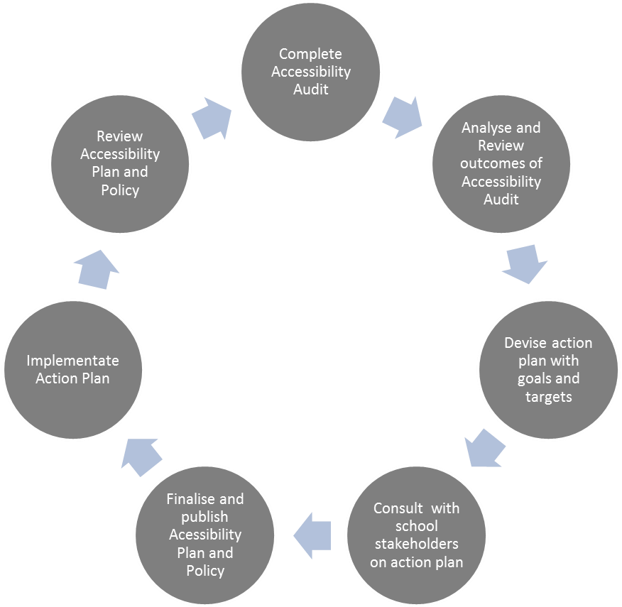

IDENTIFYING BARRIERS TO ACCESS: A CHECKLIST
This checklist comprises of three sections. In the first, you are asked to consider whether the school environment in which you work is designed to meet the needs of all pupils and/or visitors, including those with SEN and/or disability. The second and third sections should be used to identify how your school delivers its curriculum and provides written materials in alternative formats and to provide a clearer picture of the barriers to access that exist in the school culture. This list is not exhaustive.
1= yes - completely, 2 = almost - working towards meeting the guidance, 3 = partially, 4 = not yet considered.
Physical Access | Score | Evidence / Action
Are your classrooms optimally organised for disabled pupils? | 2 | Some of the older parts of the building have very small classrooms, however the best use of space is used.
Does the size and layout of the areas including all academic, sporting, play, social facilities-classrooms, the assembly hall, library, playgrounds, common rooms allow access for all pupils | 1
Can pupils that use wheel chairs or mobility aids move around the school without experiencing barriers to access such as those caused by doorways, steps and  stairs, toilet facilities and showers | 2 | Internal doors would need to be held open. Old part of the building has narrower doorways.  There is a disabled toilet and shower room in the main entrance of the building.  Room 20 has a fire exit with steps, this would not be acceptable to exit for a wheelchair user
Are pathways of travel around the school sight and parking arrangement safe with routes logical and well signed | 1
Are emergency and evacuation systems set up to inform all pupils, including pupils with SEN and disabilities, including alarms with both visual and auditory components | 1 | Alarms have a flashing light as well as the bell.  PEEP in place for key pupils
Are non-visual guides used, to assist people to use the buildings including lifts with tactile buttons | N/A
Could any of the décor or signage be considered to be confusing or disorientating for disabled pupils with visual impairment, autism or epilepsy? | N/A
Are areas to which pupils should have access well lit? | 1
Are steps made to reduce background noise for those pupils with sensory needs such as considering a rooms acoustics and noisy equipment? | 2 | Audiological assessment completed.
Is furniture and equipment selected, adjusted and located appropriately? | 1 | Different year groups have different size furniture. Foot rests are used for those who struggle with chair height within Year 3
Are quiet rooms/calming rooms available to children who need this facility? | 1 | Pastoral support room is fully accessible to all
Are car park spaces reserved for disabled people near the main entrance? | 1 | However these are used for staff/visitors
Are there any barriers to easy movement around the site and to the main entrance? | No
Are steps needed for access to the main entrance? Y/N Do all those steps have a contrasting colour edging? | No | Main entrance is at ground level. Stairs to the upstairs classrooms are colour contrasted.
If there are steps, is a ramp provided to access the main entrance? | N/A
Is there a continuous handrail on each ramp and stair flight and landing to the main entrance? | N/A
Is it possible for a wheelchair user to get through the principal door unaided? Y/N  If no, is an alternative wheelchair accessible entrance provided? | Y | Main entrance and door way into main building are electric, with accessible button to open back out in main foyer.
Do all internal doors allow a wheelchair user to get through unaided? | No | We do not have children or adults that are unaided moving around the school
Do all the corridors have a clear unobstructed width of 1.2m? | Yes
Does the school have a wheelchair accessible toilet? | Yes
Does the block have accessible changing rooms/shower facilities? | Yes
How many storeys in the block? Tick appropriate box: a = single storey throughout b = single storey with some split level parts c = single storey with some 2/3 storey parts d = mainly 2 or 3 storey? | C
If the block is on more than one level, do the internal steps/stairs have contrast colour edgings? | Yes
Is there a continuous handrail on each internal stair flight and landing? | Yes
Does the block have a lift that can be used by wheelchair users? | No
Is it possible for a wheelchair user to use all the fire exits from areas to which they have access? | No | The fire door in Room 20 has steps and therefore not accessible for a wheelchair user

Access to the Curriculum | Score | Evidence / Action
Do you provide disability awareness training to enable all staff to understand and recognise disability issues? | 2 | Flick Training/Trust Training
Do you have arrangements for teachers and teaching assistants to have the necessary training to teach and support children and young people with disabilities if required? | 1 | Training for relevant staff
Is teaching and the curriculum appropriately differentiated to meet individual needs so that children and young people make good progress? | 1
Are there a variety of activities planned for and implemented, including discussion, oral presentation, writing, drawing, problem solving, use of library, audiovisual materials, practical tasks and information | 1
technology?
Do lessons provide opportunities for all pupils to achieve and succeed? | 1
Do staff provide alternative ways of giving access to experience or understanding for children and young people with disabilities who cannot engage in particular activities, for example some forms of exercise in physical education? | 1 | This, at times, is tailored to the need of individual pupils
Do all staff recognise, understand and allow for the additional planning and effort necessary for children and young people with disabilities to be fully included in the curriculum? | 1
Are all staff encouraged to recognise and allow for the additional time required by some pupils with disabilities to use equipment in practical work? | 1
Do you provide access to appropriate technology for those with disabilities? | 1
Are school visits, including overseas visits, made accessible to all children and young people irrespective of attainment or disability? | 1
Are there robust transition arrangements for pupils coming into and leaving the school, (including transition into Early Years and transition to secondary placements)? | 1
Are there high expectations of all pupils behaviour ? | 1
Are pupils equally valued? | 1
Are School policies reviewed, updated in accordance with legislation and shared with all stake holders eg.  Anti bullying, SEND policies, health and safety, Behaviour etc | 1

Information Access | Score | Evidence / Action
Do you provide information in simple language, symbols, large print, on audiotape or in braille for pupils and prospective pupils who may have difficulty with standard forms of printed information? | 2 | Not currently in braille. Translators are available for phone calls, letters, emails and parent’s evenings.
Do you ensure that all information is presented to groups in a way which is user friendly for people with disabilities eg. By reading aloud, over head projector and describing diagrams. | 1
Do you have facilities such as ICT to produce written information in different formats? | 1
Do you ensure all staff are familiar with technology and practices developed to assist people with disabilities? | 1
Are the ‘responsible body’ aware of their duties and responsibilities under DDA? | 1

Accessibility Plan Key Recommendations
Physical access | Room 20 has a fire exit that is not accessible by children or adults in wheelchairs.
Curriculum access | Continue to develop Pupils, Parent/Carers and Staffs awareness and understanding of disability
Information access | Improve the delivery to disabled Pupils, Parents and Carers of having information readily accessible. (This must be delivered within a reasonable time and in ways that are determined after taking account of the pupils’ disabilities and any preferences expressed by them or their parents).

Access Plan- Physical Access
Time  Scale | Targets | Activities | Outcomes | By when | Who | Success criteria
Long term | To be able to access the main gates via a buzzer and/or automated system. | Investigate access to the main school entrance gate.  Contact companies regarding cost | To be able to have a main buzzer on the gate to allow accessibility to all but also to ensure increased safety for the site. | On EDP | SLT  Business manager

Access Plan- Curriculum Access
Time  Scale | Targets | Activities | Outcomes | By when | Success criteria
Long term | To ensure the school develops children’s awareness of | Awareness days in school | Children are aware of and accepting of  disabilities | ongoing | All staff, children and parents/carer s are aware of

 | disability. | To improve children’s awareness through whole school assemblies and class assemblies and circle time  Selection of books and articles that raise awareness of disabilities  Celebrate successes – Para Olympics, sporting, art etc | Children have a good understandin g and are respectful. |  | disability’s

Access Plan- Information Access
Time  Scale | Targets | Activities | Outcomes | By when | Success criteria
Short term | To ensure parents/carers have equal access to information provided by school – written material in a range of formats | All  documentation is offered in larger print for  visually  impaired  Text messages, emails and/or phone calls offered to  parents  Letters and newsletters typed in Dyslexia Friendly Font and size 12 or above  Ensure school website is accessible – | Parent/Carer letters and information is modified accordingly,  and accessible to all  Website is accessible to all and easy to navigate | Autumn  2018 | Ongoing
 |  | font, colours etc

